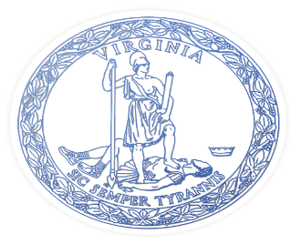
MEETING OF THE I-81 ADVISORY COMMITTEE

December 2, 2025
1:00 P.M.
Blue Ridge Community College
Robert E. Plecker Workforce Center
57 College Lane
Weyers Cave, Virginia 24486

- Call to Order
Senator Mark Obenshain, Chair of the Committee

- Discussion and Approval of Minutes from July 14, 2025
Senator Mark Obenshain, Chair of the Committee

- I-81 Corridor Improvement Program Update
Robert Williams, Virginia Department of Transportation

- Public Comment

- Closing Remarks
Senator Mark Obenshain, Chair of the Committee

MEMBERS OF THE I-81 ADVISORY COMMITTEE

Voting
Delegate Bill Wiley, District 32
Delegate Terry Austin, District 37
Delegate Sam Rasoul, District 38
Delegate Jason Ballard, District 42

Senator David Sutterlein, District 4
Senator Mark Obenshain, District 2
Senator T. Travis Hackworth, District 5

Chair Frank Friedman, Central Shenandoah PDC
Chair Phil North, Roanoke Valley/Alleghany PDC
Chair Hil Johnson, New River Valley PDC
Chair Dennis Morris, Northern Shenandoah PDC
Chair Steven Gobble, Jr., Mount Rogers PDC

Ray Smoot, Jr., Salem District CTB Member
Tom Fowlkes, Bristol District CTB Member
John P. Good Jr., Staunton District CTB Member

Ex Officio
Stephen Brich, Commissioner of Highways, VDOT
Tiffany Robinson, Director, DRPT

